Customer Shopping Behavior Analysis
1. Project Overview
This project analyzes customer shopping behavior using transactional data from 3900 purchases across various product categories. The goal to uncover insights into spending patterns, customer segments, product preference and subscription behavior to guide strategic business decision.
2. Dataset Summary
- Rows: 3900 - Columns: 18 -Key Features: - Customer demographic (Age ,Gender, Location, Subscription Status ) - Purchase detail (Item Purchased, Category, Purchase Amount, Season , Size, Color) - Shopping Behavior (Discount Applied, Previous Purchased, Frequency of purchased, Review Rating , Shipping Type) - Missing Data: 37 values in Review Rating Column .
3. Exploratory Data Analysis Using Python
We began with data preparation and cleaning in Python:
. Python Libraries: using python libraries like Numpy, Pandas. . Data Loading: Imported data using Pandas. . Initial Expression : Used df.info ( ) to check structure and df.describe for summary . statics .
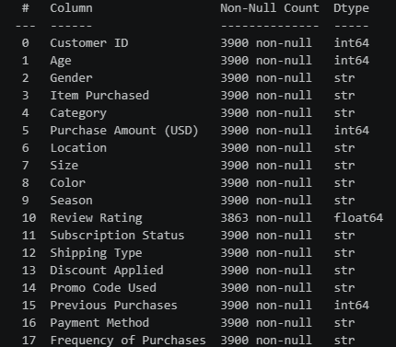

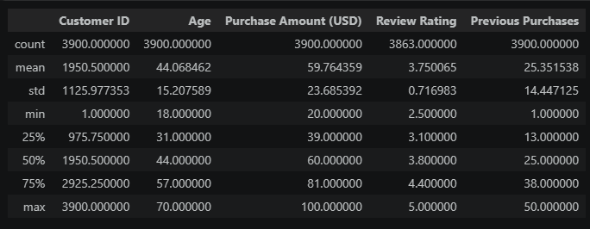

. Missing Data Handling: Checked for null values and imputed missing values.
. Column Standardization : Renamed columns to snake case for better readability and documentation.
. Feature Engineering:
- Created age_group column by binning customer age
- Created purchase_frequency_days column from purchase data.

4. Data Analysis Using SQL
We performed structured analysis in MySQL- Workbench to answer key business question:
1. Revenue by Gender - Compared total revenue by male VS female customer.
2. High Spending Discount Users - Identified customer who used discount but still spent above the average purchase amount
3. Top 5 Product by Rating – Found products with the highest average review rating.
4. Average Purchase Amounts – We Compare the average Purchase Amounts between Standard and Express Shipping.
5. Subscribers VS Non-Subscribers - Compare average spend and total revenue
Between subscribers and non-subscribers customer
6. Discount Dependent Product – Identify 5 products have the highest percentage of purchases with discounts applied.
7. Customers Segmentation - Classified customer into New, Returning, and Loyal based on their total number of previous purchases history.
8. Top 3 Products per Category – listed top 3 most purchased products within each category.
9. Repeat Buyers and Subscribers – Check whether customer with >5 purchases are more likely to subscribe.
10.Revenue by Age Group – Calculate total revenue by each age group.

5. Dashboard Using PowerBI

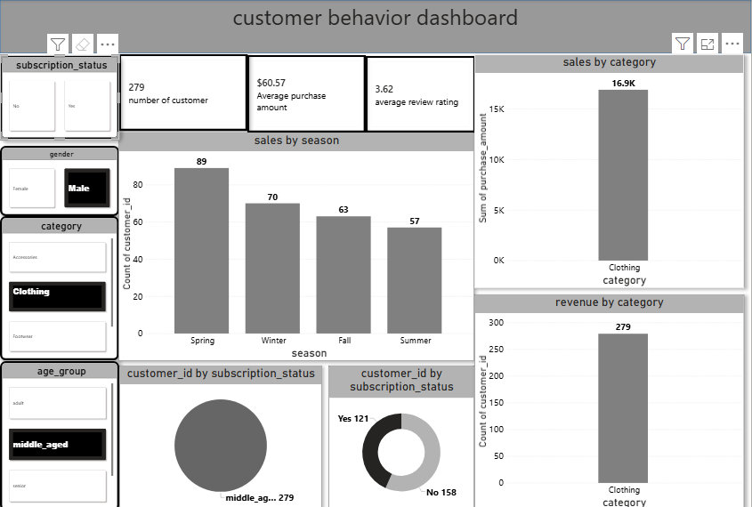

6. Business Recommendations
- Boost Subscription – Promote exclusive benefits for subscribers
- Customer loyalty Programs- Reward repeat buyers to move them into loyal.
- Review Discount Policy- Balance sales boost with margin control.
- Product Positioning – Highlight top-rated and best selling products in campaigns
- Targeted marketing- Focus effort on high-revenue age groups and express-shipping users.

